DRNS 2019 Annual Conference | Supported by the SSA
Drugs research: priorities for the future | 25th November 2019 Radisson Blu Hotel  Glasgow

Conference report Introduction
On the 25th November 2019, the Drugs Research Network Scotland (DRNS) held their second annual conference titled Drugs research: priorities for the future. Supported by the Society for the Study of Addiction, the one-day conference was designed to help the Scottish drugs research community to produce more effective and impactful research. The day included a series of presentations and workshops, as well as academic posters authored by researchers from across the UK. The event was fully subscribed, and we hosted around 140 delegates, including academic and peer researchers, Masters and PhD students, researchers from the NHS, third sector service providers, and people with lived/living experience of drug use. This report provides a summary of the event. All conference outputs, including videos and slides from presentations, graphics and photographs are available on the DRNS website at drns.ac.uk/conference2019/

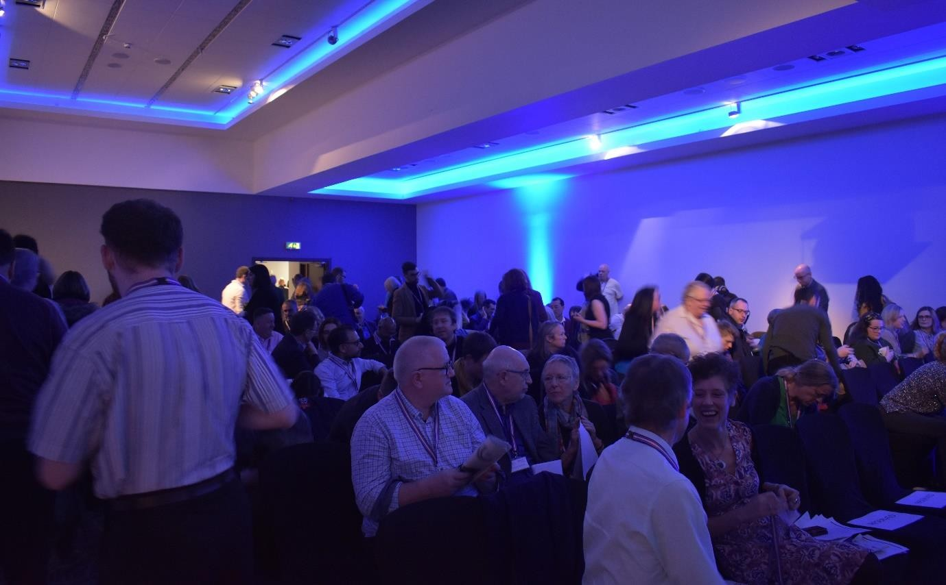

Conference programme
09.15 – 09.45 Registration and refreshments
09.45 – 10.00 | Welcome  Prof. Catriona Matheson, DRNS Convenor.  Opening Address  Mr Joe Fitzpatrick MSP, Minister for Public Health, Sport and Wellbeing, Scottish Government.
10.00 – 10.30 | Plenary Speaker  Professor Roy Robertson, University of Edinburgh  What research has led to policy or practice changes that improved the lives or care of your patients?
10.30 – 11.00 | Plenary Speaker  Dr Magdalena Harris, London School of Hygiene & Tropical Medicine  Researching injecting related risk and protection: the importance of peer and community involvement.
11.00 – 11.20 | Break
11.20 – 12.50 | Parallel Sessions  Families. Chair: Dr Anne Whittaker, University of Stirling.  Health, Social Care & Wellbeing. Chair: Dr Alison Munro, University of Dundee.  Harms. Chair: Dr Aileen O’Gorman, University of the West of Scotland.  Blood Borne Viruses. Chair: Dr Emily Tweed, University of Glasgow.  Prevention. Chair: Professor Betsy Thom, Middlesex University London.
12.50 – 13.45 | Lunch
13.45-14.15 | Plenary Speaker  Professor Adam Winstock, University College London  Scotland and the challenges of moderation.
14.15 -14.45 | Plenary Speaker  Professor Fiona Measham, University of Liverpool  Partnerships in Research: reflections on unlikely, unusual and productive partnerships.
14.45-15.00 | Coffee/tea available (to take into workshop sessions)
 | WORKSHOP SESSIONS
15.00 – 16.30 | A. An introduction to realist evaluation  Dr Fiona Harris, University of Stirling.
B. Literature review methodologies
Dr Steve McGillivray, University of Dundee.
C. An introduction to complex systems thinking
Dr Mark McCann and Dr Claudia Zucca, University of Glasgow.
- Putting peers at the centre of research on reducing harms: reflections on the SHARPS project
Josh Dumbrell, Wez Steele, Peer Navigators, The Salvation Army. Dr Hannah Carver, University of Stirling.
- Academic Input to the Drug Related Death Crisis
Professor Catriona Matheson, University of Stirling.
16.30 – 16.45 | Closing notes  Dr Tessa Parkes, DRNS Deputy Convenor and Professor Anthony Shakeshaft, University of New South Wales, Sydney, Australia.

Plenary presentations

All the plenary presentations are available on the DRNS website and linked here:

Patient care: What research and policy initiatives have made a difference?
Professor Roy Robertson, University of Edinburgh.

Researching injecting related risk and protection: the importance of peer and community involvement
Dr Magdalena Harris, London School of Hygiene & Tropical Medicine.

Scotland and the challenges of moderation
Professor Adam Winstock, University College London.

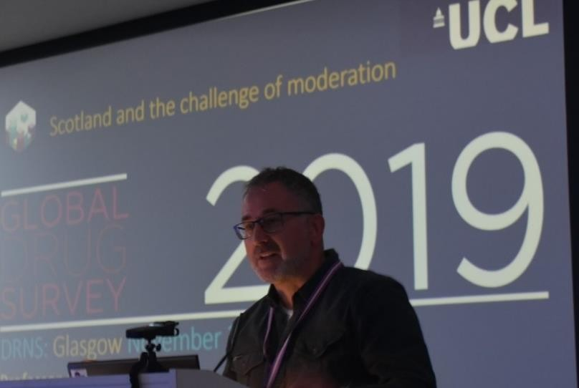

Partnerships in Research: reflections on unlikely, unusual and productive partnerships
Professor Fiona Measham, University of Liverpool.

Parallel session summaries

Families
Chair: Professor Anne Whittaker, University of Stirling, DRNS Families Theme Lead. Current research includes pregnant women, children, mothers, fathers and family members affected by substance use.
The following presentations were given during the session:
- Dr Louise Marryat, Centre for Clinical Brain Sciences, Edinburgh Neuroscience, Edinburgh University : Developing a new cohort of children born to women who used opioids in pregnancy using administrative data: insights into cohort creation and linking of administrative datasets.
- Penelope Laycock, University of Strathclyde: Adult Children of Problem Drinkers in Glasgow: Preliminary Findings.
- Katherine Long, Corra Foundation: Connections are Key: Unlocking the Heart of Relationship- Based Practice.
- Professor Anne Whittaker: Engaging opioid-dependent men in a whole family parenting and child welfare intervention: lessons learned from the PuP4Dads study.

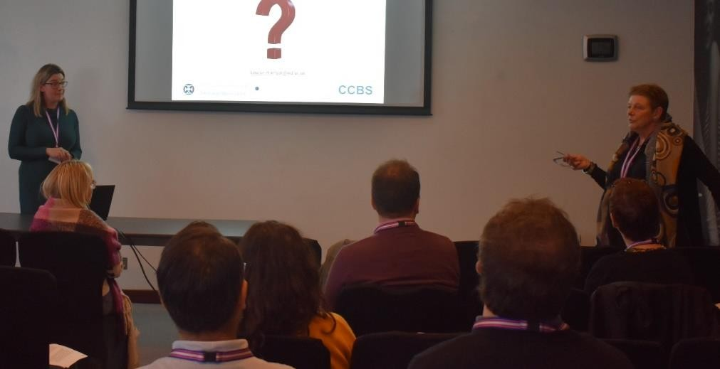

Health, Social Care & Wellbeing
Chair: Dr Alison Munro, University of Dundee, DRNS Health, Social Care and Wellbeing Theme Lead.
This session presented research on factors affecting the health, social care and wellbeing of people who use drugs. These include exploring barriers to care, the influence of systems and services on uptake and outcomes of treatments and factors associated with recovery from multiple disadvantage. In her introduction to this session, Alison outlined the diverse set of tasks associated with this area and suggested that commonalities are found.
The following presentations were given during the session:
- Andrew Radley, NHS Practitioners, with collaborators from University of Dundee, “Clinical effectiveness of Pharmacy-led versus conventionally delivered antiviral treatment for Hepatitis C in patients receiving opioid substitution therapy”. He highlighted the complex range of factors underlying effectiveness and the importance of treating patients with dignity and respect, alongside the practicalities of being able to access treatment from pharmacies

and its positive impact. He discussed the possibilities of being able to provide medication assisted treatment to large numbers of patients. He demonstrated how this pharmacy led approach was an accessible and valued community asset.
- Cassandra Baino, Scottish Graduate Entry Medicine, “Evaluating and communicating Hepatitis C Cascades of Care data: A journey towards elimination in Tayside, Scotland”. Cassandra produced a novel, systematic way of codifying Hepatitis C Virus (HCV) data and a way of communicating with a Cascade of Care. She shared the HCV data in Tayside, Scotland, to provide examples of insights gained from communicating data in this way. She described the importance of understanding the journey of people with Hep C and asked what the next steps could be for people in recovery.
- Dimitar Karadzhov, PhD Candidate, Centre for Health Policy, University of Strathclyde, “‘False Strength': Exploring the Role of Problem Substance Use in the Personal Recovery in Adults Transitioning out of Chronic Homelessness: A Transatlantic Qualitative Study.” Dimitar’s research is a collaboration with the Citizenship, Recovery and Inclusive Society Partnership (CRISP) and sets out to understand the experience of personal recovery in individuals with serious mental illness who have been chronically homeless. He is interested in understanding the lived experience and how mental health and substance use affect drug recovery.
- Dr Trina Ritchie, Lead Clinician, Greater Glasgow and Clyde Alcohol and Drug Services, “Barriers to Optimal Methadone and Buprenorphine Doses”. Trina highlighted the work that is currently taking place via peer research with people who use services and with staff through focus groups. She highlighted some of the issues with NHS staff feeling stressed and outlined parental training as important and discussed how we can talk about drugs and ensure schools have useful information, which captures the reality of substance use.

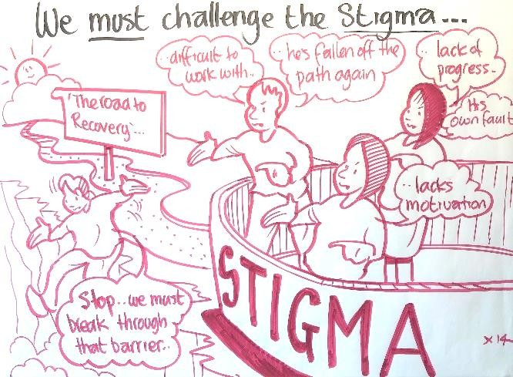

Harms
Chair: Dr Aileen O’Gorman, University of the West of Scotland, DRNS Harms Theme Lead.

The Harms session focussed primarily on the broader social harms associated with drug use and drug- related deaths and the risk environment inhabited by people who use drugs in Scotland. This session took the form of panel presentations followed by small group discussions with the session participants.
- Dr Aileen O’Gorman, “Risk environments and social autopsies: the context of drug-related harms and drug-related deaths”.
- Kirsten Trayner, PhD Candidate, Glasgow Caledonian University and Honorary Epidemiologist, Health Protection Scotland, “Increased risk of HIV and other drug-related harms associated with injecting in public places”.
- Rowan Anderson, “Gender specific harms: the experience by women who use drugs”.
- Frances Matthewson, Public Health and Deborah Stewart, NHS Highland, “Drug related deaths of young people in NHS Highland”.
- Dr Eilidh Moir, Drug Death Analyst, NHS Tayside, “Drug related deaths in Tayside”.

Blood Borne Viruses
Chair: Dr Emily Tweed, University of Glasgow, DRNS Blood Borne Viruses Lead. The following presentations were given during the session:
- Madeleine Caven, University of Dundee, “Impact of Hepatitis C treatment on substance use and injecting behaviour: a systematic review”.
- Dr Norah Palmateer, NHS Tayside, “Reduction In The Population Prevalence Of Chronic HCV Among People Who Inject Drugs Associated With Major Scale-Up Of Direct-Acting Antiviral Therapy In Community Drug Services”.
- Madeleine Caven, University of Dundee, “Hepatitis C Diagnosis and Treatment, Impact on Engagement and Behaviour of People Who Inject Drugs, the Hooked C project”.
- Jennifer Kelly, Pharmacist Independent Prescriber, Glasgow Alcohol Drug Recovery Service, “Eliminating Hepatitis C in at risk groups - Achieving 100% testing in city centre opioid agonist therapy cohort and ensuring successful linkage to treatment”.

Prevention
Chair: Professor Betsy Thom, Middlesex University London DRNS Prevention Theme Lead.
Following a short introductory talk, the session offered participants an opportunity to consider what is needed to develop drug prevention policy, practice and research at national and local levels. In her presentation “Prevention approaches in Scotland – where to now?” Betsy outlined that substance use prevention aims to stop or delay people from beginning to use psychoactive substances. It can also help those who have started to use to avoid the development of substance use disorders and associated health and social problems. Prevention also has a broader intent: to encourage the healthy and safe development of children and young people, so they can realise their talents and potential. It does this by helping them positively engage with their families, schools, peers, workplace and society.

Workshop summaries

An introduction to realist evaluation
Dr Fiona Harris, University of Stirling
The question of what difference context makes to outcomes was asked. This question was explored and unpacked during this workshop with reference to ‘realist evaluation’. Attendees were introduced to the methodology and taken through practical applications of this theory-driven approach. ‘Context- Mechanism-Outcomes’ (CMO) configurations were developed through group discussion.

Literature review methodologies
Dr Stephen MacGillivray, University of Dundee
Steve introduced attendees to the fundamental skills required to carry out a systematic review. He covered the early key methodological stages of undertaking a systematic review, specifically: (i) how to formulate review questions; (ii) how to construct and run searches for relevant literature; (iii) how to screen the literature; and (iv) how to report the findings of the search.
Steve outlined the databases which are used for reviews and the many different types of reviews. He described that they can be thought of as both systematic and unsystematic, qualitative or quantitative or both. A systematic review should be a robust, reproducible synthesis of research, and be both methodological and rigorous. He described the process of designing a protocol, as the most important part of the review and the question asked within this as the most important part of the protocol. The Research strategy should focus on Population, Intervention and Comparison.

An introduction to complex systems thinking
Dr Mark McCann and Dr Claudia Zucca, University of Glasgow
In their introductory talk, Mark and Claudia explained the meaning of the term ‘complex systems thinking’ and the methods and tools used to adopt this approach. The workshop gave an overview of how systems thinking works and provided some practical examples of how to use systems thinking in practice.
Their talk highlighted the importance of complex systems thinking for population health as it draws attention to the fact that relationships between the components of a system are not uni-causal and one directional but are related in multiple and complex ways, often instable and changing. A ‘system’, they suggested, can be defined in many ways e.g. a road system, a hospital clinic or GP surgery, a system of processes. Some systems are ‘simple’ e.g. the road system in Glasgow –which could be compared with the road system in Manhattan along a number of dimensions. Complex systems generate many different interactions –including possibly some outside the system. For instance, complex systems thinking is appropriate for looking at drug related deaths, where multiple factors from individual to policy and systems level factors interact to result in the national picture of drug- related deaths. This formed the topic of the small group discussions that followed the presentation.
The tasks were carried out in small groups without full feedback so answers may have differed between groups. (They are available on the feedback sheets). The main point of the exercise was to let participants get the feel for how complex systems thinking worked and how to go about it.

Putting peers at the centre of research on reducing harms: reflections on the SHARPS project
Josh Dumbrell, Wez Steele, Peer Navigators, The Salvation Army. Dr Hannah Carver, University of Stirling.
Peer Navigators Josh and Wez shared their experiences as Peer Navigators as part of the National Institute for Health Research funded SHARPS study (Supporting Harm Reduction through Peer Support). They discussed their experiences of being involved in the co-design of a psychologically informed peer led harm reduction intervention, and in the day to day running of the study which included recruiting and retaining participants, and data collection. They offered insights on all these aspects from their perspective as peers. Josh and Wez then facilitated a group discussion/activity, focusing on how peers could be more fully and meaningfully involved in research, across all stages of the research process.

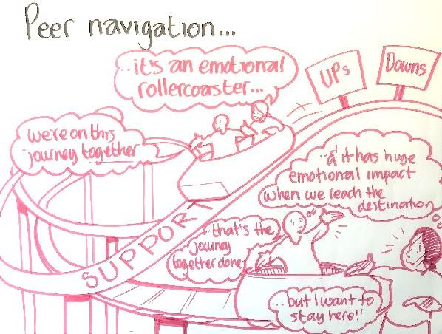

Academic Input to the Drug Related Death Crisis
Professor Catriona Matheson, University of Stirling.
Professor Matheson’s session focused on the role of academics in responding to the DRD crisis. The challenge of missing evidence was discussed along with challenges plus issues delegates wanted to raise
- Competition for metabolic pathways.
- Effect of mega-doses
- Consistency of toxicology evaluations/reporting
- How do we communicate harm reduction information effectively and reduce risk of unintended consequences?
  - Challenge of multi-agency coordination.
  - Framing concerns correctly through objective reporting and networks

- Experience of care/children in custody in NDRDD
- A&E studies of drugs other than NPS
- Audit as well as research, to find out whether standards for treatment and care are being met
- Lots of evidence already exists in ADPs.
The importance of timelines and potential solutions to effect these were also discussed:
- Using secondments not tenders would be faster
- Harnessing latent workforce – Masters students and registrar projects
- Using network to disseminate project opportunities
- More resources for collecting and releasing data – no increase in findings commensurable to increase in number of deaths, therefore, fresh data is needed. View that the current DRD reporting is not fit for purpose in 2019
- Using network to support dissemination and publication of local work
- An executive lead that is accountable for DRD doesn’t currently exist
- Protecting time of staff responsible for this as currently they are ‘maxed out’.

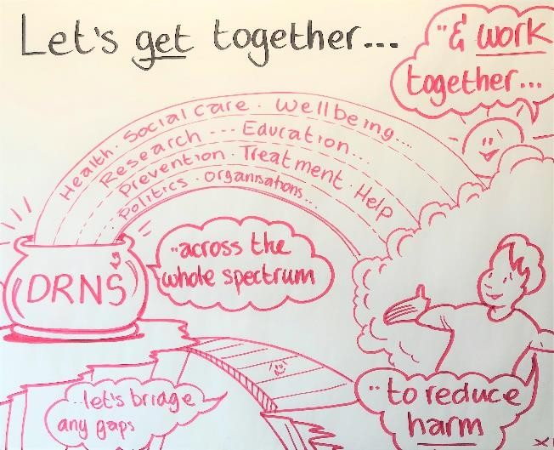

Closing notes
Closing notes were given by Dr Tessa Parkes, Deputy Convenor, DRNS in which she outlined how the constructive discussion throughout the day had brought together important discourse regarding drugs research and our priorities going forward. A summary was given by Professor Anthony Shakeshaft, University of New South Wales, Sydney, Australia. The aim of the event was to share knowledge to help shape policy and practice informed by an understanding of peoples’ needs. He gave examples of DRNS goals being operationalised, as seen during the conference. These goals include informing policy

and practice with robust evidence; and fostering knowledge exchange, for example, by hosting events like this. Understanding and responding to the needs of those with lived experience would be important in aligning these goals with practice. Anthony outlined that as DRNS approaches a potential second phase, it is faced with both challenges and opportunities. He suggested that DRNS should retain its firm focus on impact, positively impacting Scotland’s drugs problem by developing and enhancing the evidence base. Anthony also gave an overview of the challenges and opportunities for DRNS going forward:
- Roy R: need to at least consider radical change?
- Parallel sessions: lack of evidence about ‘what works’
- Reflect on the DRNS model?
- Why Most Clinical Research Is Not Useful (PLoS Medicine)

In the context of this, Anthony asked, how much descriptive research do we need before we act?

Posters
DRNS were delighted to welcome the following authors who each displayed a poster of their drug related research during the conference. The posters were judged by Dr Gillian Tober, Addiction Psychologist, trainer and co-founder of RESULT.
Cassandra Baiano from Scottish Graduate Entry Medicine was awarded the prize for best poster,
£200 towards conference attendance and other professional development activities.

O R A L A N D P O S T E R P R E SE N T A T I O N S
Martin | Anderson | Evaluating the implementation of the San Patrignano drug recovery model in Scotland.
Cassandra | Baiano | Evaluating and Communicating Hepatitis C Cascades of Care Data: A Journey Towards Elimination in Tayside, Scotland.
Harriet | Bloomfield | Understanding the motivations and context behind non-prescribed benzodiazepine use in the UK: a mixed-methods analysis.
Hannah | Carver | Supporting harm reduction through peer support (SHARPS): Testing the feasibility and acceptability of a peer-delivered, relational intervention for people with problem substance use who are homeless, to improve health outcomes, quality of life and social functioning, and reduce harms.
Madeleine | Caven | Hepatitis C Diagnosis and Treatment, Impact on Engagement and Behaviour of People Who Inject Drugs, the Hooked C project.
 |  | Impact of Hepatitis C treatment on substance use and injecting behaviour: a systematic review.
Sarah | Donaldson | A Geographic Information System (GIS) mapping exercise to assess the need for Injecting Equipment Provision (IEP) services and overdose prevention activities  in Tayside.
 |  | "Ask a Friend” Identifying the hidden population: Former intravenous drug users who are no longer in contact with services. A respondent driven sampling protocol.
Dimitar | Karadzhov | Dual recovery in Problem Substance Use and Homelessness.

Penelope | Laycock | Adult Children of Problem Drinkers in Glasgow: Preliminary Findings.
Katherine | Long | Connections are Key: Getting to the Heart of Relationship-Based Practice
Louise | Marryat | Developing a new cohort of children born to women who used opioids in  pregnancy using administrative data: insights into cohort creation and linking of administrative datasets.
Frances | Matthewson | Review of Drug Related Deaths (DRD) of Younger People in Highland (age 16-25)
Joanna | Miler | Provision of peer support at the intersection of homelessness and substance use  services: a ‘state of the art’ review.
Eilidh | Moir | Drug Deaths in Tayside: An ongoing analysis.
Norah | Palmateer | Reduction In The Population Prevalence Of Chronic HCV Among People Who Inject Drugs Associated With Major Scale-Up Of Direct-Acting Antiviral Therapy  In Community Drug Services.
Claire | Parks | Unexpected Detection of Fentanyl in Fatalities in Scotland.
Andrew | Radley | SuperDOT-C: Pharmacy-led versus conventionally delivered antiviral treatment for hepatitis C in patients receiving opioid substitution therapy.
Using a systems-thinking approach to elucidate programme theory underpinning the effectiveness of SuperDOT-C: a pharmacy-led test and treat pathway for
people with hepatitis c infection prescribed opioid substitution therapy.
Trina | Ritchie | Eliminating Hepatitis C in at risk groups - Achieving 100% testing in city centre opioid agonist therapy cohort and ensuring successful linkage to treatment.
 |  | Improved recovery outcomes with injectable prolonged-release buprenorphine in an opioid agonist therapy clinic in Glasgow.
 |  | Novel benzodiazepine-type drug use in opioid agonist clinics in Glasgow.
Joe | Schofield | Developing national research infrastructure and activity: the role of a new drugs research network.
Alice | Seywright | Synthetic Cannabinoid Receptor Agonists in Post-Mortem Casework in Scotland.
Kirsten | Trayner | Increased risk of HIV and other-related harms associated with injecting in public places: national bio-behavioural survey of people who inject drugs.
Emily | Tweed | How does ‘inclusion health’ feature in UK-relevant policy reviews of health inequalities? A document analysis.
Anne | Whittaker | Engaging opioid-dependent men in a whole family parenting and child welfare intervention: lessons learned from the PuP4Dads study.

Feedback
We are grateful to delegates who took the time to complete our post-event feedback form. It was great to read your positive comments and thoughtful suggestions for future DRNS conferences. Positive feedback generally focussed on the following:
- The event was relevant to delegate’s knowledge and practice/studies.
- The workshop and parallel sessions were considered to be very good.
- There was felt to be a good mix of academic research and more qualitative input on lived experience.
- Delegates appreciated the chance to hear about work being done by around Scotland and the network opportunities this allowed.
Common suggestions for change for next year’s event were:

- The evident issues with the venue, which detracted from the event content.
- Improved use of the roving mic, as some audience questions could not be heard.
- Several suggestions for a different venue than Glasgow, as it has been held there for the last two years.
- It was felt that more opportunities for early career researchers within the forum would be good, perhaps including a dedicated poster session.
All feedback received is being used to inform future events.

Acknowledgments
We would like to offer our sincere thanks to all our speakers, workshop facilitators, and poster authors for sharing their knowledge and experiences on the day. For helping us to capture the conference content, we are grateful to our video recorder and editor Alex Dunedin; our photographer Rory Matheson; our graphic illustrator Graham Ogilvie and all our volunteers who helped take notes.
Thanks also go to the Society for the Study of Addiction for supporting the event and, last but not least, we would like to thank all of our delegates for attending our second annual conference and making the event a success through their attendance, networking and contributions.

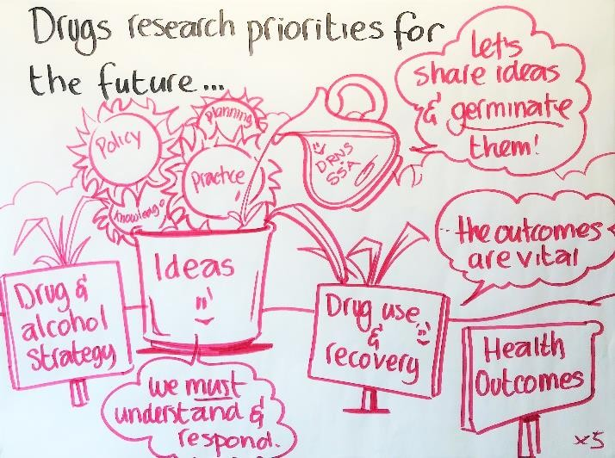

Delegate list
At the time of booking, all delegates were asked to indicate if they consented for their details to be included in the conference report. This delegate list includes details of those who gave opt-in permission and who provided full contact details.

First Name | Surname | Job Title | Company
Martin | Anderson
Marie | Wilson
Emma | Fletcher | Consultant in Public Health  Medicine | NHS Tayside
APRIL | SHAW
Andy | Perkins | Director | Figure 8 Consultancy Service Ltd
Justina | Murray | CEO | Scottish Families Affected By Alcohol and Drugs
John | Burns
Matthew | Gilbert-Straw | Grant Advisor | Corra Foundation
Matt | Jay
Kayleigh | Lavornia
Dimitar | Karadzhov
John | Holleran | Families & Communities Manager | Scottish Families Affected by Alcohol & Drugs
colin | hepburn | Student | Glasgow Kelvin College
zoe | swithenbank | PhD Student | Liverpool John Moores University
Wendy | Masterton | PhD Researcher | University of Stirling
Faith | Ougham | student | UWS
Gillian | Burton | PhD Student | University of Stirling/GCU
Tess | Parkes | Director | Salvation Army Centre for Addiction Services and Research
David | Orr |  | Ethypharm
Margaret | Graham McDonald | Fellow | EUPATI
Vic | Walker | Head of Service | CrossReach
Bashiru | Sani | Student | University of Glasgow
Tracey | Price | PhD Researcher | University of Stirling
Jo | McManus | Health Improvement Senior | NHS Greater Glasgow and Clyde
Trevor | Lakey | Mental Health & Inequalities Manager | NHS Greater Glasgow and Clyde
Anne | Savage | Lecture | Abertay University
Lisa | Williams
Anthony | Shakeshaft | Deputy Director | National Drug and Alcohol Research Centre, UNSW, Australia
Catherine | Foley | Research Fellow | National Drug and Alcohol Research Centre, UNSW,  Australia
Emily | Tweed | Clincal Lecturer/PhD researcher | MRC/CSO Social and Public Health Sciences Unit
Penelope | Laycock | Phd Student | University of Strathclyde
Adelle | Still
harriet | Bloomfield
Sarah | Lawson | Trainee Clinical Psychologist | NHS Lanarkshire
DAVID | LIDDELL | CEO | Scottish Drugs Forum
Aileen | O’Gorman | Senior Lecturer/Programme  Leader CDAS | University of the West of Scotland

Duncan | Hill | Specialist pharmacist in substance misuse | NHS Lanarkshire
Amy | McEwan | PhD Student | Glasgow Caledonian University
Robin | Falconer | MPH Student | University of Stirling
Lauren | Buntrock | Student | UWS
Stephen | Russell | Senior Addiction Worker | East Dunbartonshire CHCP, UWS Postgrad Student
Maria | Munro | Student | University of West of Scotland
Ambreen | Bonnet | Student | UWS
Iain | Smith | Locum Consultant Psychiatrist | NHS Forth Valley
fraser | gallacher | Student | University of the West of Scotland
Gaby | Vella | Therapeutic Facilitator | Caritas Malta
Anwar | Rashid
Fiona | Wylie | Forensic Toxicologist | Forensic Medicine and Science, University of Glasgow
Denise | McKeown | Forensic Toxicologist | Forensic Medicine and Science, University of Glasgow
Alice | Seywright | Forensic Toxicologist/PhD  Student | Forensic Medicine and Science, University of Glasgow
Lauren | O'Connor | Forensic Toxicologist/PhD Student | Forensic Medicine and Science, University of Glasgow
Jodie | McGarry | Phd Student | Glasgow Caledonian University
Claire | Adams | Student | University of west of scotland
Catriona | Matheson | DRNS Convenor | U of Stirling
Andrea | Connolly
Sarah | Donaldson | PhD student | University of Dundee
Joanna | Miler | Knowledge Exchange Fellow | SACASR University of Stirling
Hannah | Carver | Lecturer in Substance Use | University of Stirling
Maria | Fotopoulou | Lecturer in Criminology | University of Stirling
Bhags | Shara | Consultant Psychiatrist in  Addiction Medicine | NHS Fife
Louise | Marryat | Research Fellow | University of Edinburgh
Tim | Elworthy | Consultant Psychiatrist | NHS Tayside
Joe | Schofield | Research Coordinator | Drugs Research Network for Scotland
Helen | Murodch | Housing First Operation Manager Scotland | The Salvation Army
Laura | Mitchell | Drug and Alcohol Operations  Manager - Scotland | The Salvation Army
Catriona | Ritchie | Lead Clinician | NHS Greater Glasgow & Clyde
Hazel | Harris | Retired | Hazel Harris
Amie | Tait | Family Outreach Worker | Circle
Miriam | Lloyd | Admin Asst
Madeleine | Caven | Student | University of Dundee
Anthony | Christie | Researcher | University of Glasgow
Fiona | Cowden | Consultant | NHS Tayside
Roy | Robertson |  | University of Edinburgh
Magdalena | Harris |  | LSHTM
Adam | Winstock |  | UCL
Fiona | Measham |  | Liverpool University
Adrian | Crofton | GP | Aberdeen Health and Social Care Partnership
Stephanie | Dargan | Research Assistant | NHS Greater Glasgow & Clyde

Mhairi | Russell | Medical student | University of Glasgow
Ryan | Frize | Medical Student | University of Glasgow
Christopher | Airth | Information Analyst | NHS NSS
Jaroslaw | Lang | Senior Information Analyst | NHS NSS
Alison | Munro |  | Dundee University
Emma | Coles |  | University of Stirling
Rosaleen | Obrien |  | Glasgow Caledonian University
Kevin | Gardiner | Researcher | Figure 8 Consultancy
Stephen | MacGillivray | Associate Professor | University of Dundee
Joshua | Dumbrell | Peer Navigator | Salvation Army
Wesley | Steele | Peer Navigator | The Salvation Army
Mark | McCann | Research Fellow | University of Glasgow
Claudia | Zucca | Research Assistant | Glasgow University
Fiona | Harris | Associate Professor | University of Stirling
Frances | Matthewson | Research and Intelligence Specialist | Highland Alcohol and Drug Partnership
Gordon | Hay | Reader in Social Epidemiology | Liverpool John Moores University
Cassandra | Baiano
Norah | Palmateer |  | Glasgow Caledonian University
Katherine | Long
Anne | Whittaker | Assoc. Professor | Stirling University
Eilidh | Moir
Trina | Ritchie
Claire | Glen | SHSP | NHS Lothian
Kathryn | Machray | Intern | Health and Social Care Analysis
Donna | Ross | Project Manager | Healing for the Heart
David | Black
Lee | Barnsdale | Principal Information Analyst | PHI (Health & Social Care Team), NSS, NHS
Maggie | Page | Senior Research Officer | Health and Social Care Analysis
Nicholas | Formosa
Karen | Black | Citizenship & Research manager | TurningPoint Scotland
Heather | Still | Alcohol & Drug Researcher | Arran Community and Voluntary Service
Callum A | MacCall | Consultant Forensic Psychiatrist | State Hospital
Deborah | Stewart | Coordinator | Highland Alcohol and Drug Partnership
Steph | Ratcliffe | Manager | St Mungos
Nick | Fuller | Lecturer | University of the West of Scotland
Maame | owusuaa | PhD Student | RGU
Susan | Weir | Senior Officer National Quality Development Team | Scottish Drugs Forum
Rowan | Anderson | Partnership Drugs Initiative  Manager | Corra Foundation
Betsy | Thom | Professor | Middlesex University London
Hector | Williams | Researcher | Independent Researcher
Peter | Hillen | Lecturer | Edinburgh Napier University
Andrew | McAuley | Sr Research Fellow | Glasgow Caledonian University

