First Annual Conference |  | Supported by the SSA
Maximising the impact of Scottish drugs research:  from inception to publication |  | 28th November 2018 Grand Central Hotel  Glasgow
 | P R O G R A M M E
09.15 – 09.45 | Registration and refreshments
M O R N I N G P L E N A R Y : C h a i r e d b y D r A l i s o n M u n r o , U n i v e r s i t y o f D u n d e e
09.45 – 10.00 | Welcome  Prof. Catriona Matheson, DRNS Convenor
10.00 – 10.30 | Research into policy: some examples of success  Prof. Alex Stevens, University of Kent
10.30 – 11.00 | Getting good ideas into practice: how is implementation science useful for service improvement?  Prof. Tracy Finch, Northumbria University
11.00 – 11.20 | Poster presentations
11.20 – 11.45 | Break
WORKSHOP SESSIONS
11.45 – 12.45 | A. Democratising drugs research? Navigating the evidence and building on people's experience to make it work for everyone  Jason Wallace, Scottish Drugs Forum Dr Gillian Tober, Leeds Addiction Unit Dr Tessa Parkes, University of Stirling
B. Preparing a strong grant application
Prof. Kate Hunt, University of Stirling
C. The power of large datasets and data linkage
Lee Barnsdale, NHS Information Services Division Suhail Iqbal, Administrative Data Research Centre
12.45 – 13.45 | Lunch
A F T E R N O O N P L E N A R Y : C h a i r e d b y D u n c a n H i l l , N H S L a n a r k s h i r e
13.45 – 14.15 | Getting published: A how-to guide  Prof. Betsy Thom, Middlesex University
14.15 – 14.45 | Using non–academic methods in knowledge exchange  Prof. Harry Sumnall, Liverpool John Moores University
14.45 – 15.05 | Poster presentations
15.05 – 15.30 | Break
WORKSHOP SESSIONS
15.30–16.30 | D. Research ethics and governance in drugs research  Dr Anne Whittaker, University of Stirling
E. Communicating research effectively with policy makers
Carol Brown, Scottish Government
F. Research into policy and practice: Successful case studies from a clinical/practitioner perspective
Prof. Roy Robertson, University of Edinburgh David Liddell, Scottish Drugs Forum
16.30 – 16.45 | Closing notes Joe Schofield, DRNS Coordinator

M E E T T H E S P E A K E R S
Professor Alex Stevens
Alex is Professor in Criminal Justice at the University of Kent. He is a member of the UK Advisory Council on the Misuse of Drugs and President of the International Society for the Study of Drug Policy. He has published extensively on drug policy issues, including drug services in prisons, decriminalisation in Portugal and the recent increases in drug-related deaths in the UK. These publications include a book on Drugs, Crime and Public Health: the Political Economy of Drug Policy (Routledge) and, most recently, an article called ‘Drug Policy Constellations’ in the International Journal of Drug Policy.

Research into policy: some examples of success (10.00-10.30)
We are all familiar with examples of research being blocked from informing policy. But there are examples of success. These include: the long spread of opioid substitution therapy (including in prisons); the adoption of harm reduction in response to the HIV epidemic; and the international spread of support for decriminalisation of drug possession. This talk will focus on the mechanisms through which research makes its way into policy, including professional pressure, community mobilisation, legal action and relatively enlightened democratic processes. It will emphasise that mere publication of research is never enough. It will invite discussion of whether and how such successes can be replicated for
present problems, including record levels of drug-related deaths.
Professor Tracy Finch  Tracy is Professor of Healthcare & Implementation Science in the Department of Nursing, Midwifery & Health, at Northumbria University, Newcastle upon Tyne. Tracy is known for her work in implementation science, most notably Normalization Process Theory (NPT), of which she is co-developer. This work includes applying theoretical perspectives and novel research methodologies to understand and shape the processes of healthcare improvement through implementation of changes in practice, across a range of topics (eg mental health, e-health, patient safety, stroke therapy). Central to this, is development and application of theory based tools and assessment instruments to support non-academic users conducting implementation work in practice settings; and development of qualitative and mixed methods process evaluation methodology in relation to development and evaluation of complex interventions.  Getting good ideas into practice: how is implementation science useful for service improvement? (10.30-11.00)  New innovations in health and social care provision promise improvement in service user outcomes, yet fail to be successfully integrated into routine practice. The presentation will provide a brief introduction to ‘implementation science’ and outline how the theoretical and practical developments in this field can help us to better understand – and influence – efforts to create and sustain change in practice. One key approach within the field, Normalization Process Theory (NPT) (http://normalizati onprocess.org) will be described and illustrated with brief  examples, as a tool for planning and evaluating complex health interventions. | 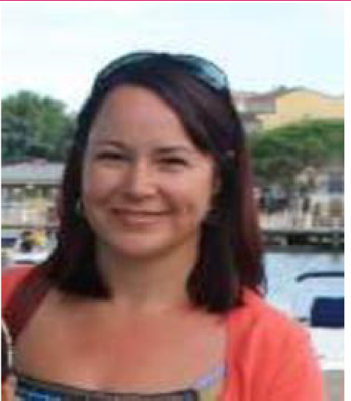

Professor Betsy Thom  Betsy is Professor of Health Policy and co-director of the Drug and Alcohol Research Centre at Middlesex University. Her research interests include alcohol and drug policy, gender and substance use, and community based approaches to prevention and intervention. She has been involved in several EU funded projects and has worked as a consultant for UNODC. She was editor-in-chief of Drugs: Education Prevention and Policy for twenty years and a member of the board of the International Society for Addiction Journal Editors (ISAJE). Her work has included developing and running distance learning programmes in drug and alcohol studies; most recently a masters in ‘Comparative Drug and Alcohol Studies’, a collaborative programme with Denmark and Italy. Current research is looking at drug prevention interventions for young drug users in the criminal justice systems in six EU countries.  Getting published: A how-to guide (13.45-14.15)  The presentation will highlight some dos and don'ts in three key areas: choosing a journal; preparing your manuscript; and replying to reviewers' comments. Come  prepared with questions you want to raise. | 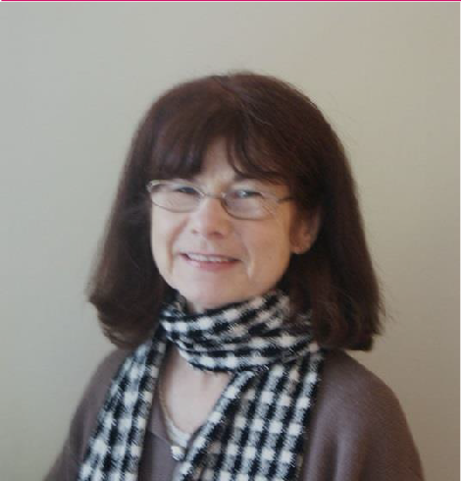
Professor Harry Sumnall
Harry is Professor in Substance Use at the Public Health Institute and Liverpool John Moores University. His research focuses on young people's substance use, with a general interest in prevention interventions and mechanism to support the use of evidence in practice and policy. Ongoing research projects include evidence-based risk communication campaigns, development of opioid-prescription reduction programmes in primary care, and understanding the representations of substances in popular media. Harry is a member of the UK Government Advisory Council on the Misuse of Drugs (ACMD), a Board member of the European Society for Prevention Research (EUSPR), a Trustee of the drug and alcohol prevention charity Mentor UK, and a Scientific Advisory Board member of the MIND Foundation.

Using non–academic methods in knowledge exchange (14.15-14.45)
Traditional dissemination routes are rarely effective in helping researcher's to improve their knowledge exchange activities. Drawing upon recent examples in the substance use field, this talk will discuss some of the opportunities and challenges of alternative knowledge exchange practices, including social media, art & music, broadcasting, as well as the evidence underpinning more structured dissemination
programmes.

 | M O R N I N G W O R K S H O P S ( 1 1 . 4 5 - 1 2 . 4 5 )
A | Democratising drugs research? Navigating the evidence and building on people's experience to make it work for everyone  Workshop Facilitators: Jason Wallace (Scottish Drugs Forum), Dr Gillian Tober (Leeds Addiction Unit) and Dr Tessa Parkes (University of Stirling)  This one hour workshop will explore different approaches to involving people with living and lived experience of drug problems in drugs research with their associated benefits and challenges. We will share insights from our own experience on ways to try to make involvement work for everyone involved. In exploring some of the tricky issues in this work we will draw on literature that can help us to be attentive to, and try to actively address, power as well as  structural inequalities.
B | Preparing a strong grant application  Workshop Facilitator: Prof. Kate Hunt (University of Stirling)  This interactive workshop will provide an overview of the key things to bear in mind when preparing a grant application. Participants will be encouraged to discuss and debate how to build a strong case for funding, what funders might be looking for, what might frustrate reviewers, where to look for help, how to plan and manage input from co-applicants,  and how to best use research support.
C | The power of large datasets and data linkage  Workshop Facilitators: Lee Barnsdale (NHS Information Services Division) and Suhail Iqbal (Administrative Data Research Centre)  National administrative datasets on health-related activity are an important source of information for National and Official drug-related statistics. However, their potential contribution to impactful public health research can best be realised via data linkage with other drug-related health and non-health data sources. This talk describes examples of data linkage using drug-related administrative health data and outlines the process for applying to utilise these data sources for academic research.
 | A F T E R N O O N W O R K S H O P S ( 1 5 . 3 0 - 1 6 . 3 0 )
D | Research ethics and governance in drugs research  Workshop Facilitator: Dr Anne Whittaker (University of Stirling)  This interactive workshop will provide an overview of the UK Research Governance Framework for Health and Social Care and important ethical considerations in drugs research. Participants will be encouraged to discuss and debate handling challenging issues in studies which involve drug-using populations such as capacity to consent, confidentiality and anonymity, handling sensitive topics, child and adult protection, power and coercion, incentive payments, working in risky environments and researcher safety, data protection and security, managing adverse events, as well as common  ethics violations and how to avoid them.
E | Communicating research effectively with policy makers  Workshop Facilitator: Carol Brown (Scottish Government)  This session is for researchers who want to explain their findings clearly to non-specialists, especially policy makers, to increase their impact. The session will cover: knowing your purpose, knowing your audience, planning and structuring your work. It will include some ‘real world examples’, hints, tips and anecdotes, as well as the chance to put this learning  into practice.
F | Research into policy and practice: Successful case studies from a clinical/practitioner perspective  Workshop Facilitators: Prof. Roy Robertson (University of Edinburgh) and David Liddell (Scottish Drugs Forum)  During this workshop, David and Roy will draw upon their own experiences to discuss how drugs research can successfully influence policy and practice. David will explain how research conducted by SDF has influenced government thinking including levels of investment and the need for trauma informed services. Roy will discuss policy and national strategy documents have been informed by his work on the Edinburgh Cohort study and an epidemiological study of  HIV/AIDS in a group of heterosexual people who have injected drugs.

M E E T T H E W O R K S H O P F A C I L I T A T O R S
Jason Wallace, Scottish Drugs Forum
Jason is the newly appointed Senior Development Officer at Scottish Drugs Forum (SDF) after working for many years at SDF as the National Naloxone Training Support Officer and as a volunteer peer researcher. He successfully completed SDF’s award winning Addiction Worker Training Project and has a SVQ 2 in Health and Social Care and a SVQ 4 in Learning and Development. He chairs the National Volunteer Forum on Drug-Related Deaths, and was a member of the National Forum on Drug-Related Deaths and the National Naloxone Advisory Group in Scotland now disbanded. Jason is currently a co-investigator on a research project that tests the feasibility and acceptability of a peer delivered relational intervention for people with problem substance use who are homeless.
Dr Gillian Tober, Leeds Addiction Unit  Gillian was consultant psychologist and service manager at the Leeds Addiction Unit until the closure of the NHS service and has been Principal Investigator in a number of multi- centre treatment trials. Her research interests are in the measurement of dependence and other addiction treatment outcomes, and in the process of treatment delivery. Gillian has been responsible for the addiction training department affiliated with the University of Leeds where she is Senior Associate Lecturer. Gillian is author and co-author of research papers, book chapters and addiction treatment manuals. | 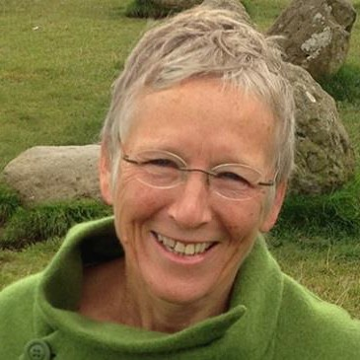
Dr Tessa Parkes, University of Stirling
Tessa has experience in the statutory and non-statutory health, social care and housing/homelessness sectors as a front-line support worker, team leader and mental health nurse, and has provided consultancy and training to a wide variety of organisations focused on service improvement to better meet the needs of healthcare users. Tessa has a track record of creating positive impact on policy and practice through research. For 20 years her research activity has centred on enhancing the experience of people who use health/social care services, with a clear commitment to social justice, health equity and advocacy for poorly serviced groups with a specialism in mental health and substance use. She enjoys seeking out opportunities to move research into action including using participatory film-making. She is Research Director for the Salvation Army Centre for Addiction Services and Research in the Faculty of Social Sciences at Stirling.
Prof. Kate Hunt, University of Stirling  Kate is Professor in Behavioural Sciences and Health at the Institute for Social Marketing at the University of Stirling and an Honorary Professor at the University of Glasgow. Kate’s research experience and interests have covered a wide range of areas, including: gender, health, health behaviours and help-seeking; designing and evaluating gender-sensitive interventions; evaluation of policy change within the Scottish prison service; and experiences of health and illness. She has received funding from various funders and has been on three funding boards in recent years: MRC’s Population and Systems Medicine Board, NIHR Public Health Research funding board, and MRC Population Health  Intervention Development Scheme. | 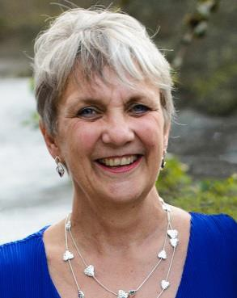
Lee Barnsdale, NHS Information Services Division
Lee is a Principal Information Analyst for ISD Scotland (part of NHS National Service Scotland). Lee and his team produce National and Official statistics on specialist drug treatment, drug-related hospital admissions, drug-related deaths, take-home naloxone and injecting equipment provision in Scotland. Lee has also been involved in a range of projects utilising data linkage (for example, drug prevalence estimation, population projections for older people with a drug problem). Lee previously worked for the University of Stirling, participating in evaluations of Drug Courts and Arrest Referral schemes. Lee is currently a member of the Partnership for Action on Drugs in Scotland Harms Subgroup and the Novel Psychoactive Substances Centre for Excellence.

Suhail Iqbal, Administrative Data Research Centre  Suhail works for the electronic Data Research and Innovation Service (eDRIS) which provides a single point of contact to assist in the completion of applications to the Public Benefit and Privacy Panel and assist researchers in study design, approvals and data access in a secure environment. eDRIS aims to make conducting research easier, more efficient and more convenient. eDRIS is part of Information Services Division (ISD) of NHS National Services Scotland. Suhail is an alumnus of UMIST, University of Nottingham and University of Edinburgh. | 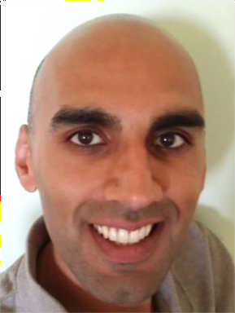
Dr Anne Whittaker, University of Stirling  Anne is an Associate Professor at the Nursing, Midwifery and Allied Health Professions (NMAHP) Research Unit, funded by the Chief Scientist Office. Anne’s research experience and interests are broadly related to addiction within the family, including pregnancy, parenting, and whole family approaches. She currently teaches a masters level module - ‘Research Ethics and Governance’ -on the MRes in Health Research programme at the  University of Stirling and was previously a member of Edinburgh Napier University’s School of Health and Social Care Ethics Committee. She has considerable experience in successfully managing studies involving complex ethical and governance issues and the NHS REC and R&D approval process. | 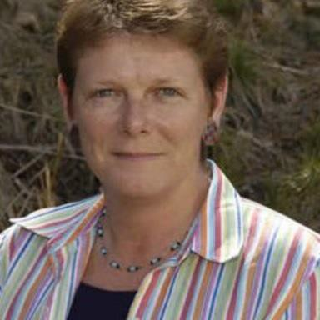
Carol Brown, Scottish Government
Carol is Principal Social Researcher in Population Health at the Scottish Government. She leads a team of researchers working on a range of health topics -including drugs, alcohol and tobacco. The job of a government analyst is about taking information and making it understandable and useful for policy makers. Carol has over ten years’ experience providing briefing for senior civil servants and government Ministers about research and statistics. She also learned a lot about communicating simply from previous work in academia, the third sector and on international projects –as well as from being a mum of two pre-schoolers!
Prof. Roy Robertson, University of Edinburgh
Roy is Professor of Addiction Medicine at the University of Edinburgh, Centre for Population Health Sciences, and Partner at the Muirhouse Medical Group in NW Edinburgh where he has been since 1980. He has a special interest in illegal drug use and associated harms including HIV/AIDS, hepatitis and drug related death. He has been a member of UK, European and WHO advisory groups and policy committees for over 30 years, was member of the ACMD for 10 years and was Chair of the Home Office Shipman committee. He was a member of the recent Departments of Health Guidelines committee on Management of Drug Misuse (and was a member of the same group in 1990 and 2007). He was chair of the Scottish “National Forum on Drug Related Deaths” until it was incorporated into the new Harms Group of the Partnership for Action on Drugs in Scotland (PADS).
David Liddell, Scottish Drugs Forum
David is the Chief Executive Officer of the Scottish Drugs Forum (SDF) and has worked in the field of drugs, alcohol, and homelessness for over 35 years in England, Ireland, and Scotland. He was a key player in the development of harm reduction services in Scotland, advocating the introduction of needle exchanges and substitute prescribing programmes. He served on the UK Government’s Advisory Council on the Misuse of Drugs from 2008 until 2017, and since the creation of the Scottish Parliament in 1999, he has been a Secretary to the Cross Party Group on Alcohol and Drug Misuse. An active member of the European Civil Society Forum on Drugs, David is a regular media commentator on issues relating to problematic drugs use in Scotland. He has contributed to a number of publications on drug use in Scotland and was made Officer of Order of the British Empire (OBE) in the Queen’s 2012 Birthday Honours for services to disadvantaged people in
Scotland.
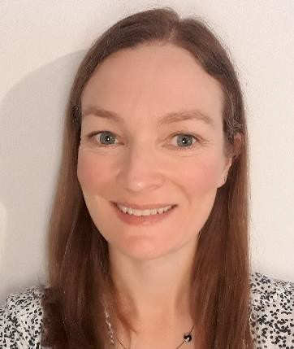

H O U S E K E E P I N G

Travel
The DRNS conference will be hosted at the Grand Central Hotel which is located at 99 Gordon Street, Glasgow, G1 3SF (see Google maps for directions). The hotel is directly above Glasgow Central train station, an 8-minute walk away from Queen Street station and an 11 minute walk away from Buchanan Street bus station. Glasgow Airport is 8 miles, or 15 minutes via cab, from the hotel. Discounted parking is available at the Glasgow Oswald Street (NCP) car park (postcode G1 4PA), at £11 for 24-hours (normally £22). Please ask the hotel reception team to validate your ticket.

Accessibility
There is step-free access to, and within, the venue and Glasgow Oswald Street (NCP) car park has five bays for drivers with blue badges. Please contact us on admin@drns.ac.uk if you would like us to provide you with a large print copy of the delegate pack and conference presentations.

Food
A hot and cold buffet lunch will be provided along with teas/coffees and light snacks throughout the day.

Wi-Fi
Free Wi-Fi will be provided by the venue (registration required).

Twitter
If you have Twitter, then please follow us on @DRNScot and tweet using the hashtag #DRNS2018.

Photography
We have arranged for a photographer to attend the event so that photographs can be taken during the day and uploaded to the DRNS website and DRNS social media. These will be used on our website and in other DRNS reports and promotional materials. Please contact us on admin@drns.ac.uk if you would prefer not to be in any photographs at the event.

Sustainability
To make our conference more environmentally sustainable, we will not be providing delegates with printed copies of the delegate pack. Instead, the delegate pack will be made available on the DRNS website. During conference registration, we will give each delegate a name badge for the day to help facilitate networking. We ask that delegates please leave their name badge behind after the conference so that these can be reused at future events.

The Drugs Research Network Scotland (DRNS) and the Society for the Study of Addiction (SSA)
This conference has been organised by the Drugs Research Network Scotland (DRNS) which supports the development and dissemination of Scottish drugs research to help inform Scottish policy, practice and community responses. The event has been supported by the Society for the Study of Addiction which aims to add to and promote the scientific understanding of addiction and problems related to it.

Event Outputs
To document the conference, DRNS will be video recording presentations and allocating scribes to take notes during workshops. These outputs will be made available on the DRNS website after the event along with presentation slides and workshop summaries.

Event Feedback
After the conference, we will email delegates with an evaluation form for delegates to provide feedback on the conference. DRNS values delegate feedback and would appreciate any suggestions that will help us to shape future conferences and events.

Contacts
To find out more information about the conference, please visit the DRNS website www.drns.ac.uk/conference.
If you have any queries, please do not hesitate to get in touch with us by email at admin@drns.ac.uk.

