Conference report
First Annual Conference | Supported by the SSA
Maximising the impact of Scottish drugs research:  from inception to publication |  | 28th November 2018  Grand Central Hotel Glasgow

Introduction
On the 28th November 2018, the Drugs Research Network Scotland (DRNS) were delighted to hold their first annual conference titled Maximising the impact of Scottish drugs research: from inception to publication. Supported by the Society for the Study of Addiction, the one-day conference was designed to help the Scottish drugs research community to produce more effective and impactful research. The day included a series of presentations and workshops, as well as academic posters authored by researchers from across the UK. The event was fully subscribed, and we hosted around 120 delegates including academic and peer researchers, Masters and PhD students, researchers from the NHS, third sector service providers, and people with lived/living experience of drug use.
This report provides a summary of the event. All conference outputs, including videos and slides from presentations, graphics and photographs are available on the DRNS website at drns.ac.uk/conference2018

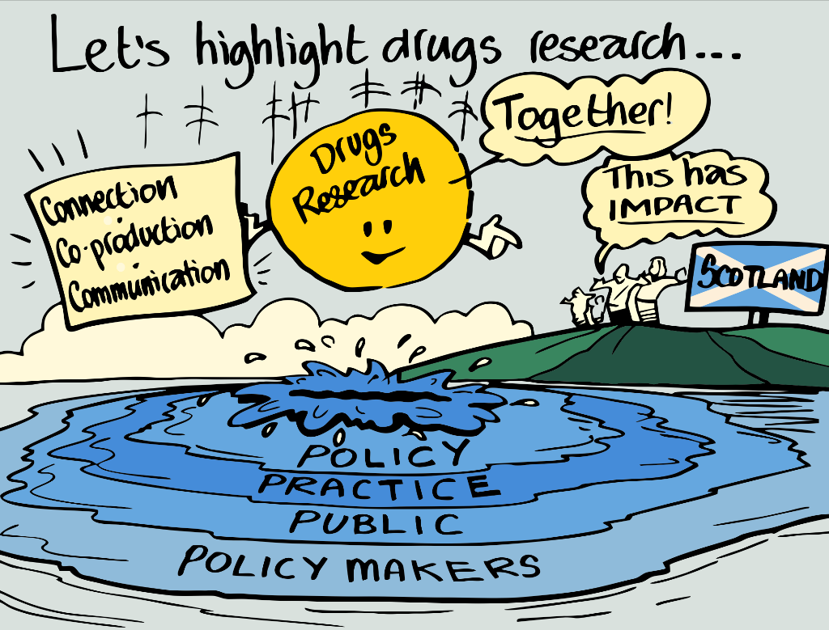
Website: https://drns.ac.uk Email: admin@drns.ac.uk Twitter: https://twitter.com/DRNScot

Conference programme
09.15 – 09.45 | Registration and refreshments
MORNING PLENARY: Chaired by Dr Alison Munro, University of Dundee
09.45 – 10.00 | Welcome  Prof. Catriona Matheson, DRNS Convenor
10.00 – 10.30 | Research into policy: some examples of success  Prof. Alex Stevens, University of Kent
10.30 – 11.00 | Getting good ideas into practice: how is implementation science useful for service improvement?  Prof. Tracy Finch, Northumbria University
11.00 – 11.20 | Poster presentations
11.20 – 11.45 | Break
WORKSHOP SESSIONS
11.45 – 12.45 | - Democratising drugs research? Navigating the evidence and building on people's experience to make it work for everyone  Jason Wallace, Scottish Drugs Forum  Dr Gillian Tober, Leeds Addiction Unit  Dr Tessa Parkes, University of Stirling
- Preparing a strong grant application
Prof. Kate Hunt, University of Stirling
- The power of large datasets and data linkage
Lee Barnsdale, NHS Information Services Division
Suhail Iqbal, Administrative Data Research Centre
12.45 – 13.45 | Lunch
AFTERNOON PLENARY: Chaired by Duncan Hill, NHS Lanarkshire
13.45 – 14.15 | Getting published: A how-to guide  Prof. Betsy Thom, Middlesex University
14.15 – 14.45 | Using non–academic methods in knowledge exchange  Prof. Harry Sumnall, Liverpool John Moores University
14.45 – 15.05 | Poster presentations
15.05 – 15.30 | Break
WORKSHOP SESSIONS
15.30–16.30 | - Research ethics and governance in drugs research  Dr Anne Whittaker, University of Stirling
- Communicating research effectively with policy makers
Carol Brown, Scottish Government
- Research into policy and practice: Successful case studies from a clinical/practitioner perspective
Prof. Roy Robertson, University of Edinburgh
David Liddell, Scottish Drugs Forum
16.30 – 16.45 | Closing notes Joe Schofield, DRNS Coordinator

Plenary presentations

Research into policy: some examples of success
The first presentation of the day was given by Professor Alex Stevens from the University of Kent. During his presentation, Alex outlined power and morality as two main barriers in drug policy, and discussed four examples of how these barriers have been successfully overcome. Examples included HIV prevention and harm reduction, New Labour’s expansion of opioid substitution treatment (OST) into English prisons, and development of medical cannabis in the UK. Alex finished his presentation with the following four lessons that we can learn from the successful examples:
- Appeal to shared interests in reducing harm.
- Present a threat to the ‘in-group’.
- Create consequences for the powerful.
- Change the narrative.
Following from Alex’s presentation, a short discussion covered topics including the puritan moralism that surrounds alcohol and drug policy, the compromises made between doctors and the Home Office, how to improve representation of people with lived/living experience of drug use in policy decisions, and the balance between facts and creating a narrative.
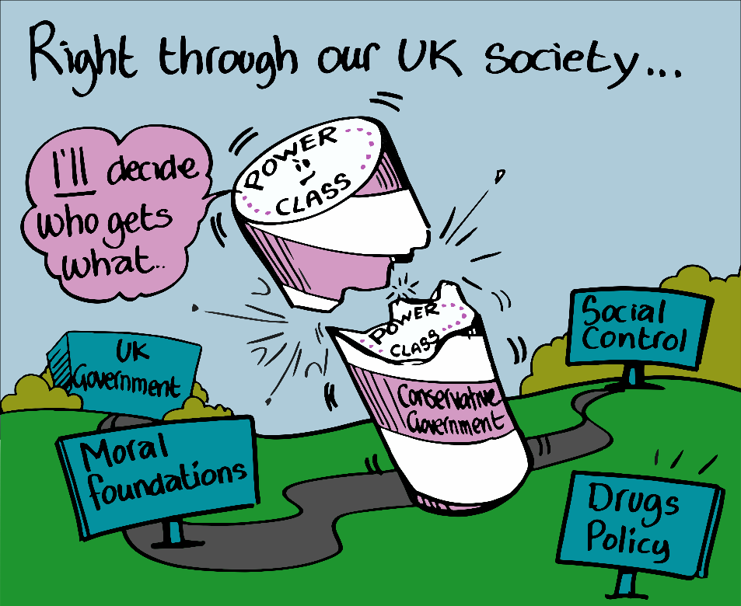

Getting good ideas into practice: how is implementation science useful for service improvement?
The final morning plenary presentation was given by Professor Tracy Finch from Northumbria University. Tracy began by defining implementation science and discussing the varied terminology, approaches, activities, and levels of analysis contained within. Tracy then discussed Normalisation Process Theory (NPT) which is a way of thinking about implementation problems that focuses on:
- how interventions can become part of everyday practice;
- how different groups of people need to work together to achieve it.
Using examples, Tracy ended her presentation by discussing how NPT can be used as a tool for planning and evaluating complex health interventions.

Getting published: A how-to guide
The first afternoon presentation was given by Professor Betsy Thom from Middlesex University. During her presentation, Betsy gave practical advice for researchers looking to get their work published. For example, advice was given on how to choose the most appropriate journal and avoid predatory publishing. Betsy then went on to discuss how to prepare your work for your chosen journal. This involved a frank discussion on how to navigate the common dilemma of authorship. Betsy also advised on how to delete unnecessary but much-loved sections of writing. To end her presentation, Betsy advised on how to respond to reviewer comments and start the revision process.
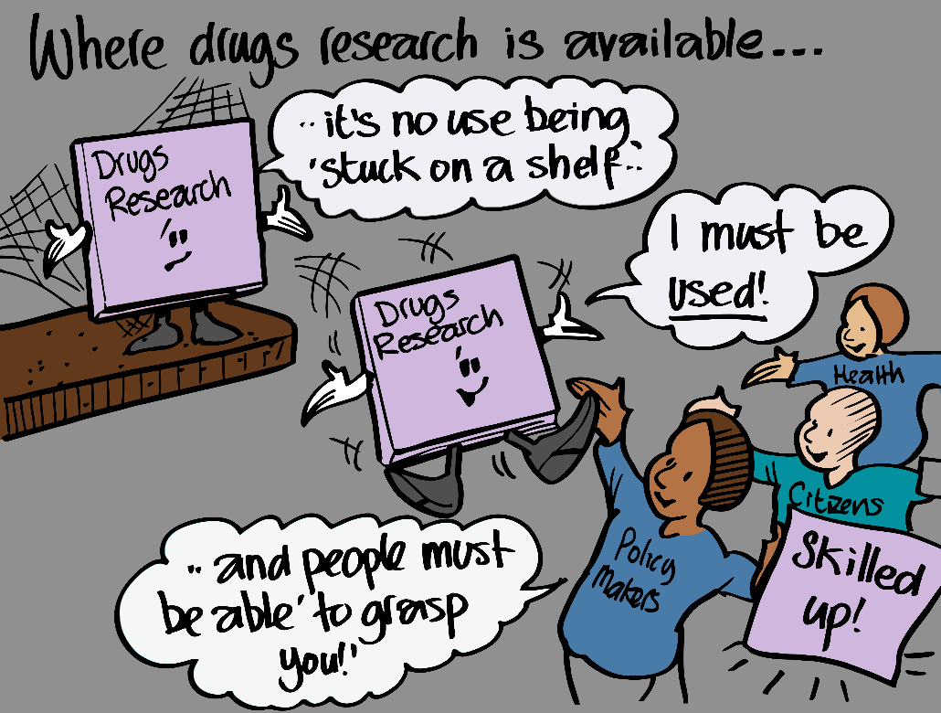

Using non–academic methods in knowledge exchange
The final presentation of the day was delivered by Professor Harry Sumnall from Liverpool John Moores University. Harry’s presentation involved a discussion of how researchers in the substance use field can improve their public engagement to effectively transfer knowledge and impact on policy. Harry highlighted the need to go beyond publishing in journal articles to promote research. Importantly, high citation numbers do not guarantee that your research will reach the public or influence policy. Presenting a range of examples, Harry demonstrated how non–academic methods can be utilised effectively to improve knowledge exchange. Example methods included Twitter, Facebook, research podcasts, YouTube, and many more. Harry finished his talk by discussing recent examples in Scotland of campaigns that have successfully engaged with the public and Government, such as #DontPinkMyDrink by the Substance Misuse group at Glasgow Caledonian University.
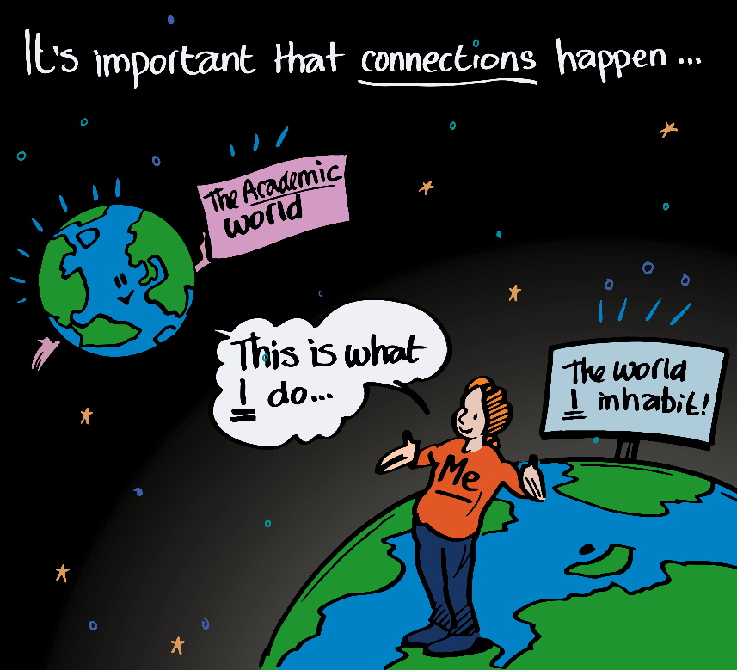

Workshop summaries

Democratising drugs research? Navigating the evidence and building on people’s experience to make it work for everyone
This morning workshop was delivered by Jason Wallace (Scottish Drugs Forum), Dr Gillian Tober (Leeds Addiction Unit), and Dr Tessa Parkes (University of Stirling). During this workshop, the facilitators drew upon their own experiences to share insights and practices that can support the research involvement of people who use/d drugs and affected family members. The workshop involved a discussion of the underpinning values, ethics, and principles surrounding involvement, with the facilitators exploring different models of involvement and their associated benefits and challenges.

Preparing a strong grant application
Professor Kate Hunt, from the University of Stirling, led a one hour workshop that taught delegates how to prepare a strong grant application. Kate’s key topics included finding out about your potential funder(s), building the case for your proposal, planning and writing your research design, considering the essential practicalities, submitting your application, and responding to referees.

The power of large datasets and data linkage
The final morning workshop was facilitated by Lee Barnsdale (ISD Scotland) and Suhail Iqbal (Administrative Data Research Centre). Lee started the workshop by outlining key substance-use related data sources such as the Scottish Drug Misuse Database (SDMD) and the Prescribing Information System (PIS). Lee discussed multiple examples of how the ISD Scotland has been able to utilise data linkage and bring together multiple drug-related data sets from different organisations to produce new findings. Discussed topics included drug prevalence estimates, drug-related deaths, and older people with a drug problem. Suhail then proceeded to outline the eData Research and Innovation Service Team (eDRIS) which is a National Services Scotland (NSS) service that provides coordination and expert advice to support researchers wishing to work with health data. Presentation slides from the workshop can be accessed below:

Research ethics and governance in drugs research
This afternoon workshop was delivered by Dr Anne Whittaker from the University of Stirling. During her workshop, Anne outlined key issues that require addressing when conducting drugs research, including participant safety, consent, and confidentiality. Anne discussed a range of different research populations and contexts and gave an overview of the ethical approval process. To close the workshop, Anne facilitated an interactive discussion of different research scenarios and their varying ethical considerations.

Communicating research effectively with policy makers
This workshop was led by Carol Brown who is a Principal Social Researcher in Population Health at the Scottish Government. Carol started the workshop by shedding valuable insight into the background of policy making and role that research plays in this process. Carol then gave specific advice on how to write effectively for policy makers, which requires a different approach when compared to typical academic style. At the end of Carol’s workshop, delegates separated into groups and critically discussed example posters and evaluated their effectiveness at communicating to policy makers.

Research into practice: Successful case studies from a clinical/practitioner perspective
The final afternoon workshop was facilitated by David Liddell (Scottish Drugs Forum) and Professor Roy Robertson (University of Edinburgh). During this workshop, David and Roy drew from their extensive backgrounds in drug research and each presented two case studies demonstrating how drugs research has been put into practice. David and Roy discussed research surrounding older people with drug problems in Scotland, trauma and recovery amongst people who have injected drugs within the past five years, the Edinburgh Drug Cohort Study, and the Muirhouse Medical Group. Both workshop facilitators identified how the discussed research has influenced practice as demonstrated in government strategy, clinical practice guidelines, and the lives of people who use drugs.
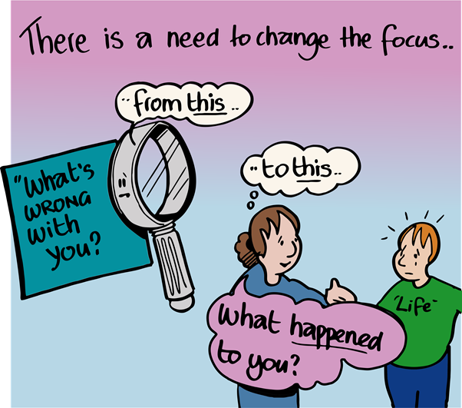

Posters
DRNS were delighted to welcome the following authors who each displayed a poster of their drug-related research during the conference. The posters were judged by Dr Duncan Raistrick who is the Co-Director of RESULT: a programme of research into outcome and process measures. Duncan has recently retired as Consultant Addiction Psychiatrist with Leeds Addiction Unit and has been involved in the addictions field since his psychiatric training which he completed in 1979.
We would like to congratulate Karen Black from the University of the West of Scotland who was awarded the prize for the best poster.
Name | Organisation | Poster Title
April Shaw | University of Glasgow | Using Object Elicitation Methods in Qualitative Interviews
Emma Hamilton | Scottish Drugs Forum | Developing a theory of social isolation and loneliness in a cohort of older male drug users.
Emma Hamilton | Scottish Drugs Forum | A Mixed Method Evaluation of NHS Tayside’s Injecting Equipment Provision Services
Hannah Carver | The Salvation Army Centre for Addiction Services and Research, University of Stirling | Perspectives of problem substance use treatment from those experiencing homelessness: Key components and missing voices
Karen Black | University of the West of Scotland | Alternative Voices of Recovery: Exploring the meaning of recovery for people on methadone treatment
Karen Dunleavy | University of the West of Scotland | Spore forming bacterial infections and people who inject drugs: Implications for harm reduction
Louise Marryat | University of Edinburgh | Stakeholder perspectives of the successes and failures of drug harm reduction policy in Scotland
Mathew Smith | Glasgow Caledonian University | Pre-exposure prophylaxis for people who inject drugs: results from an exploratory study carried out during an ongoing HIV outbreak in Glasgow, Scotland
Paul Rogon | Scottish Children's Reporter Administration & Glasgow Caledonian University | Exploring the multidimensional nature of the use of substances by young people and the associated problematic consequences.
Peter Hillen | Edinburgh Napier University | The role of personal spiritual rituals among individuals in recovery from problematic substance use: implications for drug and alcohol workers.
Rachel Barry | University of Edinburgh | Understanding cannabis policy change in Uruguay: Towards policy coherence?
Rebecca Foster | University of Stirling | Supporting harm reduction through peer support (SHARPS): Testing the feasibility and acceptability of a peer-delivered, relational intervention for people with problem substance use who are homeless, to improve health outcomes, quality of life and social functioning, and reduce harms
Tony Knox | University of Birmingham | Psychosocial Factors Influencing the Harmful Use of PIED in Sport and Exercise
Tracey Price | University of Stirling | An Exploration of Scotland's Early Interventions and Diversions
We would like to thank Paul Rogon, Karen Black, Tony Knox, Emma Hamilton, Karen Dunleavy, and Tracey Price who each delivered a short presentation of their work during the conference plenary sessions.
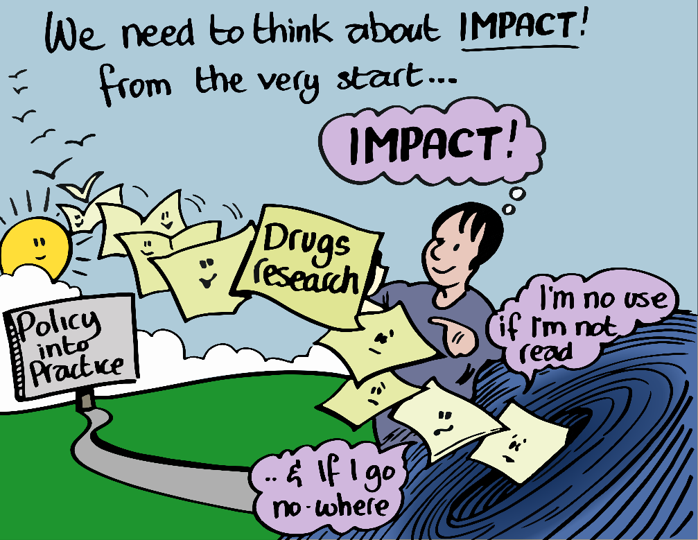

Feedback
We are grateful to delegates who took the time to complete our post-event feedback form. It was great to read your positive comments and thoughtful suggestions for future DRNS conferences. Positive feedback generally focussed on the following:
- the relaxed and friendly atmosphere that facilitated networking opportunities with peers and other professionals in the field;
- the chance to hear research findings from students and early career researchers;
- the breadth and quality of the topics covered which accommodated for people with varying interests and backgrounds.
Common suggestions for future DRNS conferences included the following:
- smaller sized workshops to allow for more interactive and discussion-based activities;
- more time allocated for poster viewing;
- a greater focus on research findings and emerging research;
- additional events tailored towards development of early career and peer researchers.
All feedback received is being used to inform future events.

Acknowledgments
We would like to offer our sincere thanks to all our speakers, workshop facilitators, and poster authors for sharing their knowledge and experiences on the day. For helping us to capture the conference content, we are grateful to our video recorder and editor Alex Dunedin; our photographer Lenny Warren; and our graphic illustrator Graham Ogilvie.
Thanks also go to the Society for the Study of Addiction for supporting the event and, last but not least, we would like to thank all of our delegates for attending our first conference and making the event a success through their attendance, networking and contributions.

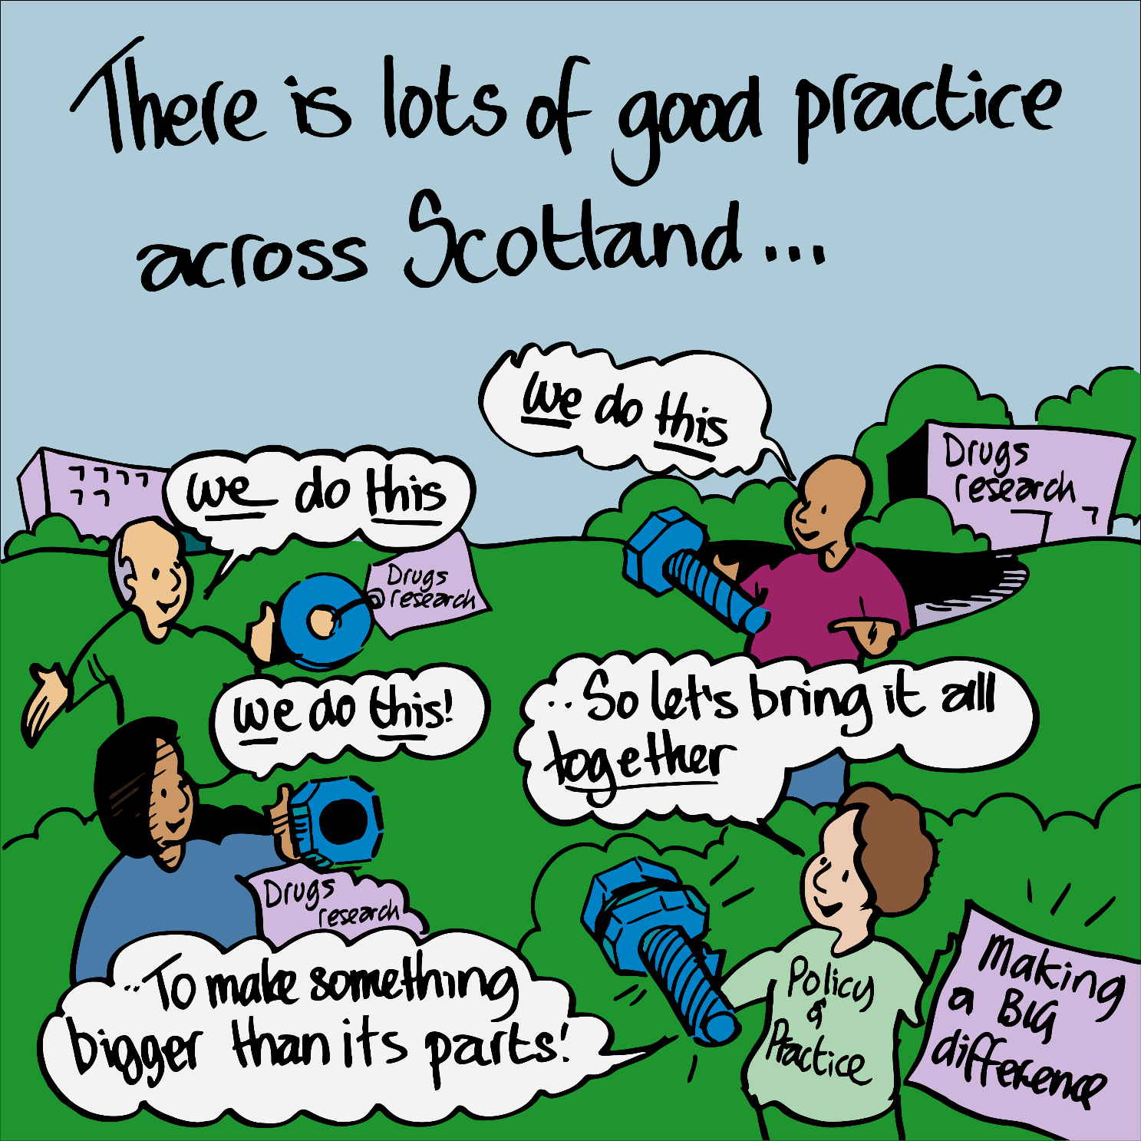

Delegate list
At the time of booking, all delegates were asked to indicate if they consented for their details to be included in the conference report. This delegate list includes details of those who gave opt-in permission and who provided full contact details.
Name |  | Job Title | Company
Laura | Adnum | Researcher (Drink Wise Age Well evaluator) | Glasgow Caledonian University
Martin | Anderson | Postgraduate Researcher (PhD) | University of Glasgow
Rowan | Anderson | Partnership Drugs Initiative Manager | Corra Foundation
Sarah | Anderson | Lecturer in Criminology | University of the West of Scotland
Liz | Aston | Director, SIPR | Edinburgh Napier University
Angus | Bancroft |  | University of Edinburgh
Lee | Barnsdale | Principal Information Analyst | NHS Information Services Division
Rachel | Barry | PhD Student | University of Edinburgh
Paul | Baxter | Peer Research Volunteer | Scottish Drugs Forum
Karen | Black | Citizenship Development Co-ordinator | Turning Point Scotland
Anna | Brewster |  | Glasgow Caledonian University
Carol | Brown | Principal Research Officer | Scottish Government
Mark | Burgess |  | Scottish Government
John | Burns | PhD Student | University of Stirling
Zoe | Carre | Policy Researcher | Release
Hannah | Carver | Knowledge Exchange Fellow | University of Stirling
Eric | Chen | Researcher | NHS Lothian
Zoe | Clarke | Project Worker/Researcher | Health Opportunities Team
Jessica | Cleary | Doctoral Student | University of Stirling
Marcus | Cusack | Knowledge Exchange Assistant | University of Stirling
Fiona | Cuthill | Lecturer in Nursing Studies | University of Edinburgh
Elinor | Dickie |  | NHS National Services Scotland
Sarah | Donaldson | Specialist Pharmacist in Substance Misuse | NHS Tayside
Gill | Donnan | Service Manager | Addaction
Alex | Dunedin | Director | Ragged University
Karen | Dunleavy | Research Fellow | University of the West of Scotland
Fraser | Edmonston |  | Scottish Drug Forum
Tracy | Finch | Professor of Healthcare  & Implementation Science | Northumbria University
Rebecca | Foster |  | University of Stirling
Maria | Fotopoulou | Lecturer in Criminology | University of Stirling
Nick | Fuller | PhD Student | University of Stirling
Wayne | Gault | ADP Lead Officer | NHS Grampian & Aberdeenshire ADP
Jennifer | Goff | Communications & Research Officer | Waverley Care
Jean | Gonzalez | Peer Researcher | SDF Scottish Drugs Forum
Rebecca | Hamer | Doctoral Researcher | CRESR, Sheffield Hallam
Janet | Hamil | Lecturer | University of Stirling
Emma | Hamilton | Head of Inclusion and Peer Engagement | Scottish Drugs Forum
Gordon | Hay | Reader in Social Epidemiology | Liverpool John Moores University
Lisa | Hendry | Outcomes Development and Information Manager | Turning Point Scotland
April | Henning | Lecturer | University of Stirling
Duncan | Hill | Specialist Pharmacist in Substance Misuse | NHS Lanarkshire
Peter | Hillen | Research Fellow | Edinburgh Napier University
Thea | House | DRNS administrative assistant | DRNS
Kate | Hunt | Professor in Behavioural Sciences and Health | University of Stirling
Elizabeth | Hurst | Policy & Comms officer | Mentor UK
Dimitar | Karadzhov | PhD Student | University of Strathclyde
Garry | Kennedy | Information Analyst | South Lanarkshire ADP
Morag | Kiltpatrick | Peer Research Volunteer | Scottish Drugs Forum
Tony | Knox | PhD Candidate | University of Birmingham
Jaroslaw | Lang | Information Analyst | NHS ISD
Lainie | Lawson | Hepatology Specialist Nurse | NHS
Penelope | Laycock | Student | University of Strathclyde
David | Liddell | CEO | Scottish Drugs Forum
Katherine | Long | Partnership Drugs Initiative: Research Intern | Corra Foundation
Leslie | MacKay | team leader (addictions) | Argyll + Bute Addictions Team
Scott | Macpherson | Lecturer | Robert Gordon University
Andriana | Manta | PhD student | University of Stirling
Louise | Marryat | Research Fellow | University of Edinburgh
Wendy | Masterton | PhD researcher | University of Stirling
Catriona | Matheson | Convenor | Drugs Research Network Scotland
Kareena | McAloney-Kocaman | Lecturer | Glasgow Caledonian University
Andrew | McAuley | Senior Research Fellow | Glasgow Caledonian University
Susie | McClue | Connecting Families Development Officer | Scottish Families Affected by Alcohol and Drugs
Amy | McEwan | Researcher | Glasgow Caledonian University
Tracey | McFall | Strategic Lead and Implementation Manager | Turning Point Scotland
Jodie | McGarry |  | Glasgow Caledonian University
Peter | McLachlan | Assistant Director | Simon Community Scotland
Tracey | McQuillian | PhD Student | University of Stirling
Heather | McVeigh | Director | Mentor UK
Kelly | Moran | Support Practitioner | Turning Point
Alison | Munro | Post-Doctoral Research Fellow | University of Dundee
Mary | Munro | Mental Health Lecturer | Robert Gordon University
Justina | Murray | CEO | Scottish Families Affected by Alcohol and Drugs
Anne | Ndlozi | Information, Research & Performance Officer | Argyll & Bute Alcohol & Drug Partnership
Joyce | Nicholson | Lecturer | University of Glasgow
Stewart | Nixon | Assistant Director | Simon Community Scotland
Aileen | O'Gorman | Senior Lecturer | University of the West of Scotland
Faith | Ougham | student | University of Stirling
Sofia | Paci | PhD student | The University of Edinburgh
Maggie | Page |  | Scottish Government
Tessa | Parkes | Director | Salvation Army Centre for Addiction Services  and Research
Christiane | Pflanz-Sinclair | PhD Student | University of Aberdeen
Duncan | Raistrick | Consultant Addiction Psychiatrist | NHS
Jenny | Revel | Mental Health Research Nurse | NRS Mental Health Network
Lisa | Rigby | Drop In Services Coordinator | Crew
Roy | Robertson | General Medical Practitioner and academic | Edinburgh University
Paul | Rogon | Research Officer | Scottish Children's Reporter Administration  & Glasgow Caledonian University
Andrew | Rome | Doctoral Researcher | University of Stirling
Anna | Ross | Convener | The Scottish Drug Policy Conversations
Lynda | Russell | Principal Clinical Psychologist | NHS Greater Glasgow & Clyde
Joe | Schofield | Research Coordinator | Drugs Research Network Scotland
Steve | Sharman | Research Fellow | University of East London
April | Shaw | PhD Candidate | University of Glasgow
Kathryn | Skivington |  | University of Glasgow
Matt | Smith | Researcher | Glasgow Caledonian University
Mike | Smith | Information Analyst | NHS ISD
Alex | Stevens |  | University of Kent
Debbie | Stewart | HADP Coordinator | Highland Alcohol and Drugs Partnership
Harry | Sumnall | Professor in Substance Use | Liverpool John Moores University
Zoe | Swithenbank | Research Assistant | University of Aberdeen
Betsy | Thom | Prof of Health Policy | Middlesex University
Carol | Thomson | Peer researcher | Scottish Drugs Forum
Gillian | Tober | Consultant Addiction Psychologist (retired) | Leeds Addiction Unit
Patricia | Tracey | Service Manager | Turning Point Scotland
Kirsten | Trayner | Researcher | Glasgow Caledonian University
Jason | Wallace | Senior Development Officer Volunteering and Engage | Scottish Drugs Forum
Nicole | Walsh | PhD Student | Edinburgh Napier University
Leanne | Watson | Volunteer peer support | Turning point Scotland
Jeanann | Webster | Assistant Director | Simon Community Scotland
Kira | Weir | Emerging Trends and Training Coordinator | Crew
Susan | Weir | Senior Officer, National Quality Development Team | Scottish Drugs Forum
Anne | Whittaker | Associate Professor | NMAHP Research Unit
Hector | Williams | Senior Research Fellow | Robert Gordon University
Barbara | Zaman | Senior Officer, National Quality Development Team | Scottish Drugs Forum

